# Machine Learning

Machine learning is defined as the field of study that gives computers the ability to learn without being explicitly programmed.The 3 main forms of learning include supervised, unsupervised, reinforcement learning.

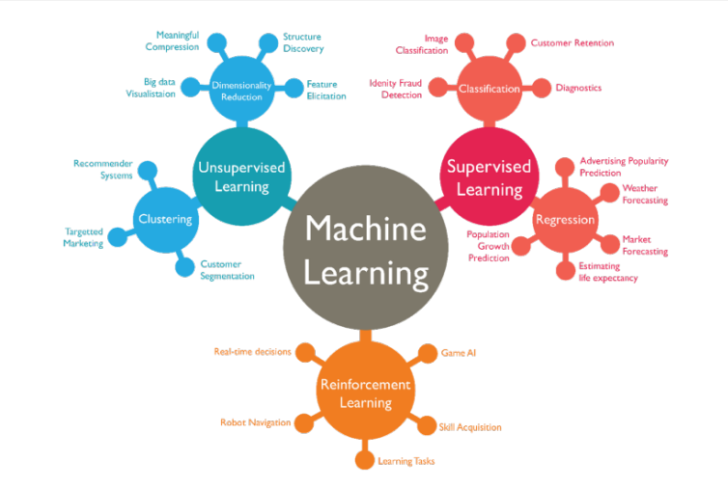

## Supervised Learning

A subset of machine learning that involves training a model to predict new outcomes using features, by training it on data that contains both the features and the outcome. The set of features is denoted as X and the outcome is Y.

The goal of this type of learning is to come out with a hypothesis function, hƟ, that approximates as accurately as possible, the real function, f, that governs the relationship between the features and the outcome.

Supervised learning has two main types: regression or classification. Regression is used to predict continuous outcomes (for example, the price of a house, lifespan of a person) while classification is used to predict distinct classes (male or female, alert or no alert, etc.) The problem we are trying to solve is a classification problem, and the model will be trained using supervised learning algorithms.

## Unsupervised learning

In unsupervised learning, the goal isn’t to predict a specific outcome but to uncover patterns in unlabeled data. Unsupervised learning helps us to discover hidden patterns or data groupings without the need for human intervention.

Its ability to discover similarities and differences in information make it ideal for clustering and visualization.

## Reinforcement Learning

In reinforcement learning, an agent learns to make decisions by interacting with its environment. The agent learns to perform a task by trial and error, without guidance from a human user. This form of learning is used to perform complex tasks that cannot be easily solved with supervised or unsupervised learning techniques like walking, driving or even playing complex games.

## Artificial Neural Networks (ANNs)

These are mathematical models for learning inspired by biological neural networks. They model mathematical functions from inputs to outputs based on the network’s structure and parameters. They allow for learning the network’s parameters based on data (training).

A neural network consists of layers, each layer consists of 1 or more neurons (node). The neurons in one layer are connected to one or more neurons in the next layer and these connections have weights. The network learns by adjusting these weights during training to map inputs to outputs.

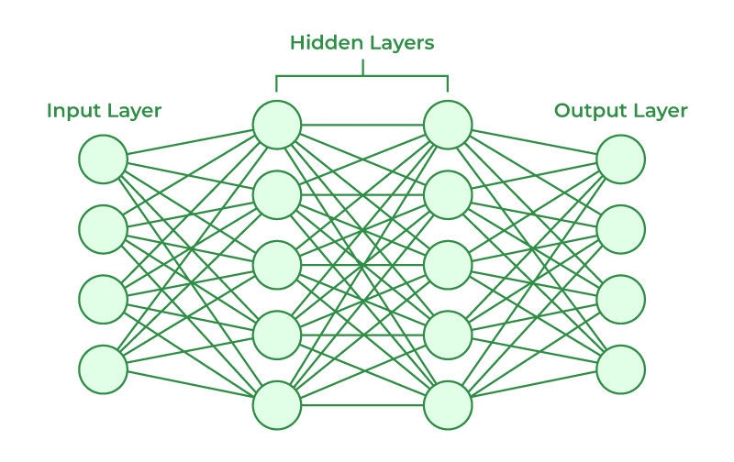

How they work:

* Input data is fed into the input layer. The number of inputs the network takes depends on the number of input nodes. The above network takes 4 inputs.
* Data propagates through the hidden layers, where neurons apply weighted sums and activation functions.
* The output layer produces predictions or classifications.

ANNs are effective for fixed-size input-output problems, where input features are consistent and independent. They excel when the relationship between inputs and output can be captured without considering sequential order or dependencies.

## Recurrent Neural Networks (RNNs)

A recurrent neural network is a deep neural network trained on sequential data to create a model that can make predictions based on data of varying lengths. RNNs can be used to solve problems such as language translation, natural language processing (NLP) or sentiment analysis.

RNNs are distinguished by their “memory” as they take information from prior inputs to influence the current input and output. The RNN tracks the context by maintaining a hidden state at each time step, this hidden state is passed from one time step to the next. At each time step, the RNN processes the current input (for example a word) along with the hidden state from the previous step, allowing the RNN to “remember” previous data points and use that information to influence the current output.

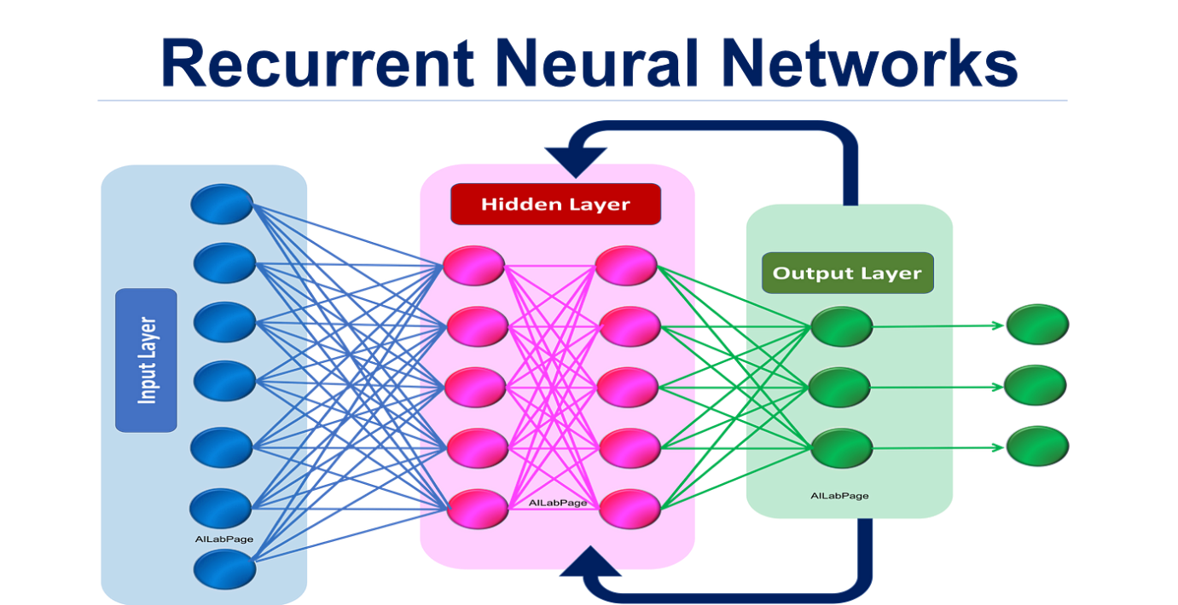

## Comparison between ANNs and RNNs

|  |  |  |
| --- | --- | --- |
| Feature | Artificial Neural Network | Recurrent Neural Network |
| Input length | Fixed size required | Variable-length sequences |
| Context modeling | Limited (treats inputs independently) | Strong (captures sequential dependencies) |
| Handling variable length | Requires padding/truncation | Naturally supported |

RNNs are most suitable for this project because of their ability to understand context in natural language as well as their support for inputs of variable lengths. The text that will be analyzed from this model will come from various sources and be of varying lengths, so it is essential to pick a model that can work with these.

